

PROJECT TITLE: HOSPITAL EQUIPMENT MANAGEMENT SYSTEM

STUDENT NAME: PRAISE ASSUMPTAH

REG NO: 2025/BCS/167/PS

STUDENT NO: 2500602891

COURSE UNIT: DATABASE SYSTEMS.

COURSE CODE: CSC 1204.

INSTITUTION: MBARARA UNIVERSITY OF SCIENCE AND TECHNOLOGY.

FACULTY: COMPUTING AND INFORMATICS.

PROGRAM: BACHELOR OF SCIENCE COMPUTER SCIENCE

SUBMISSION DATE: 06/05/2026.
HOSPITAL EQUIPMENT MANAGEMENT SYSTEM.

1. EXECUTIVE SUMMARY
The Hospital Equipment Management System (HEMS) is a centralized database solution
designed to improve the tracking, maintenance, and allocation of critical medical assets. In
modern healthcare, the availability of specialized equipment such as MRI scanners, ventilators,
and dialysis machines is directly tied to patient survival rates.
This report documents the full development life cycle of the HEMS database. This system ensures
equipment history is preserved, technicians are held accountable, and hospital management has
real-time insights into asset status. The project serves as a practical implementation of relational
and SQL principles applied to a real-world healthcare environment.
I developed this database using MySQL which performs basic data management tasks, such as the insertion, modification, and deletion of data from the relations. It also incorporates tables, relationships,
indexes and sample queries for the effectiveness of data management.

This report covers the business case, logical and physical database designs, system implementation, table descriptions, queries and their results and description.
- Business Case
Application domain of the system.
The application domain of this system is Hospital Operations and Asset Management. The system
supports the clinical engineering department by managing the maintenance schedules of life-
saving machines and tracking their locations across various hospital wings (e.g., Radiology, ICU,
Emergency).

User Groups:
• Medical Staff (Nurses/Doctors): Need to verify if a machine is operational before clinical
use.
• Biomedical Technicians: Responsible for performing repairs and logging technical data.
• Inventory Managers: Track equipment lifespans and manage supplier relationships

2b. Analysis of Benefits

It has both tangible and intangible benefits;

Tangible Benefits:
- Reduced repair costs through preventative maintenance tracking.
- Elimination of lost or misplaced portable equipment (e.g., X-ray mobiles).
- It improves maintenance planning and reduces breakdown

Intangible Benefits include;
- Increased staff confidence in the reliability of hospital infrastructure
- improves decision making through reliable database
- promotes accountability in equipment usage
- Improved patient safety due to reduced equipment failure during procedures

Analysis of cost
Tangible costs
- staff training
- system maintenance
- software setup and configuration
- hardware
Intangible costs
- Resistance to adopt new technology
- Temporary disruption during system transition.
- Time required for initial data entry

User Issues
- There is need for basic computer skills to use the system.
- Need for training requirements for both citizens and police personnel.
Users may face learning curves transitioning from traditional manual registers. Adoption effort is
minimized through a simple, menu-driven command interface and a clear, tabular React-based
- dashboard for viewing status

Risks involved within the system include;
Technical Risks:
- System failure
- Data loss if backups are maintained.
Organizational Risks.
- Lack of user acceptance.
- Poor system implementation.
Security Risks
- Unauthorized access to system data.
- Possible data breaches

Limitations:

- Depends on the availability of electricity and IT infrastructure.
- Data accuracy depends on the current user input.
- Requires continuous updates and maintenance.

Logical Design
list of entities:
- Departments
- Equipments
- Suppliers
- Technician
- Maintenance_Log
Entities and Attributes:
Equipments: Equip_ID , Name, Status, Dept_ID, supplier_ID.
- Departments: Dept_ID, Dept_Name, Floor_Location, Head_of_Dept,Contact_Extension.
- Suppliers: Supplier_ID, company_Name, Contact_Person, Address.
- Technician: Tech_ID, Tech_Name, specialty,Experience_Level, Availability.
- Maintenance_Log: Log_ID,Log_Date,Description, Equip_ID,Tech_ID.

Entity Relationships:
Departments and Equipments(1:N).
one department has many pieces of equipments.
Suppliers and Equipment(1:N).
one supplier can sell many different pieces of equipments to the hospital.
Equipment and Maintenance_Log(1:N)
one piece of equipment can have many maintenance logs( because it may break more than once).
Technician and Maintenance_Log(1:N).
one technician can write many maintenance logs

A comprehensive ER Diagram for my database.

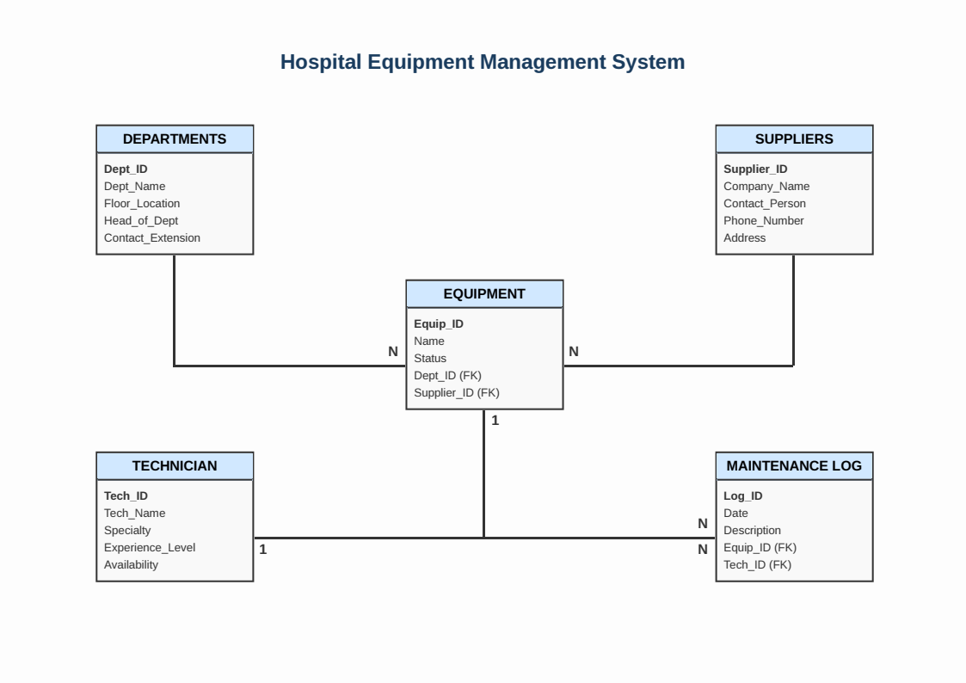

USER INTERFACE.

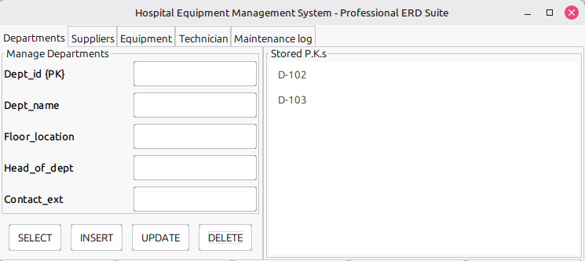

This is Departments user interface, it allows users to get all the information about the departments of the hospital.

SUPPLIER USER INTERFACE.

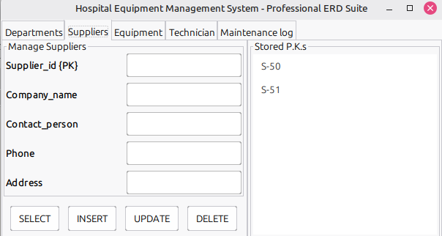

EQUIPMENT USER INTERFACE.
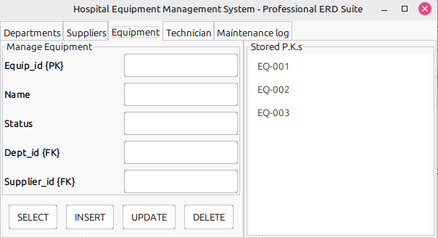

TECHNICIAN USER INTERFACE.

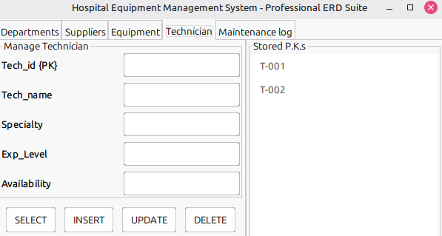

MAINTENANCE_LOG USER INTERFACE

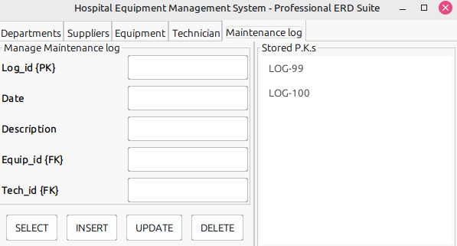
PHYSICAL DESIGN.
The following SQL code is physical implementation of Hospital Equipment Management System which creates tables for the entities mentioned above.

SAMPLE QUERIES:
SHOW DATABASES;

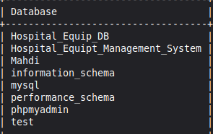

SHOW TABLES;

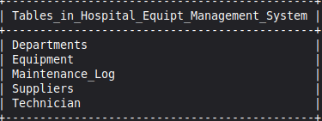

SELECT * FROM Departments;

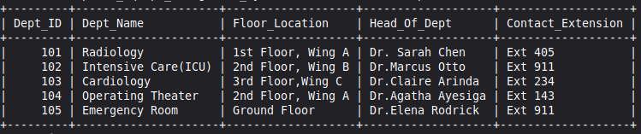

SELECT * FROM Equipment;

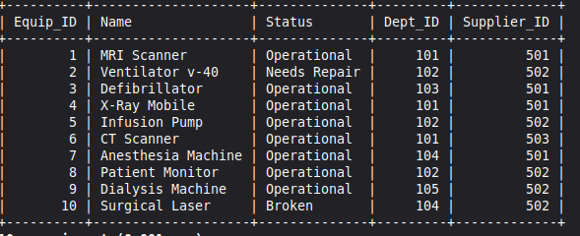

SELECT * FROM Suppliers;

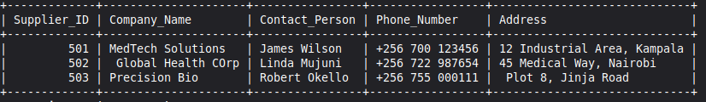

SELECT * FROM Technician;

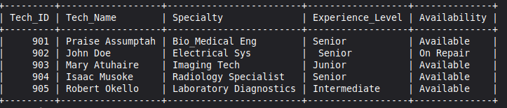

SELECT * FROM MAINTENANCE_LOG;

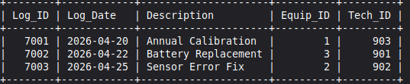

Query;
list all the equipments that currents need repair.

Sln.

Select * from Equipment WHERE Status=’Needs Repair’;

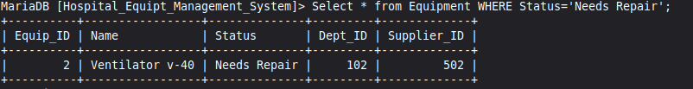

CONCLUSION.

The Hospital Equipment Management System successfully bridges the gap between complex biomedical inventory and efficient clinical workflows. By integrating a centralized SQL database with a responsive Java-based interface, the system ensures that technicians and administrators can track maintenance logs and room assignments with precision. Features such as the command console and primary key registry provide the technical flexibility required for real-time data manipulation in a high-stakes environment. Ultimately, this tool streamlines equipment oversight, reducing downtime and ensuring that critical medical machinery is always available for patient care. This foundation sets the stage for future scalability, potentially incorporating automated scheduling and advanced predictive maintenance analytics.

Bibliography

  - MySQL Documentation: https://dev.mysql.com/doc/
  - A Practical Approach to Design, Implementation, and Management Sixth edition by Thomas Connolly Carolyn Begg
  - Eclipse Foundation. (2025). Eclipse IDE for Java Developers. Retrieved from https://www.eclipse.org/
  - Database design tutorials from W3Schools.

